**Assignment 2**

**(Logic Gates & Boolean Algebra)**

**Submission Link:**

<https://docs.google.com/forms/d/e/1FAIpQLSdBHk3jQM7ylrhzpnBz-U9B5EqohCvrICbi7et9Lgm6CP34Pg/viewform?usp=sf_link>

**Submission Date: Before 11/03/2024**

**Q1 Simplify the following using Boolean rules**

 (A + B)'(C + D + E)' + (A + B)'  AB + ABC + ABCD + ABCDE + ABCDEF

(A+B+C) (D+E)' + (A+B+C) (D+E) 

 

 

 



If **AB’+A’B=C** then prove that **AC’+A’C=B**

**Q2 Express the following in canonical SOP and Canonical POS form**

F (A, B, C) = (A’+C) (A+C’) (B+C) F (A, B, C) = (A’.C) + (A.C) + (B’.C)

F (A, B, C, D) = (A’+C+D) (A+B+C’) (B’+C’+D) (A+B+D’)

F (A, B, C, D) = (A’CD)+ (ABC’) + (B’C’D) +(ABD’)

**Q3 Name the logic gate for the given truth tables and realize it using (i) NAND gates only (ii) NOR gates only**

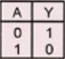 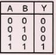 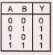 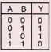 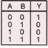

**Q4 Derive Boolean expression for the following digital circuits and sketch truth table**

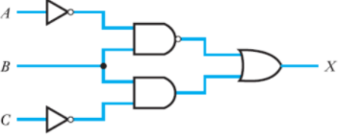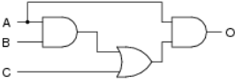

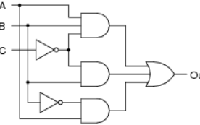 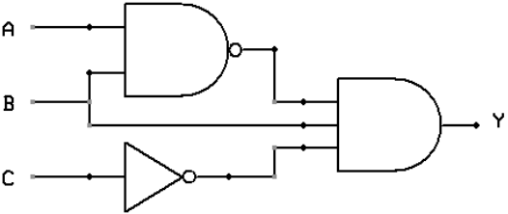

**Q5 Minimize the following by K map and realize the minimized function by (i) Basic gates (ii)NAND gate only (iii) NOR gate only**

F (A, B, C, D) = Σm (0, 1, 2, 5, 7, 8, 9, 10, 13, 15) F (A, B, C,) = Σm (0, 1, 2, 3, 6)

F (A, B, C, D) = πM (0, 1, 3, 5, 7, 8, 9, 11, 13, 15) F (A, B, C,) = πM (0, 1, 3, 5)

**Q6 Minimize the following by K map**

F (A, B, C, D) = Σm (1, 3, 4, 6, 8, 9, 11, 13, 15) + Σd (0, 2, 14)

F (A, B, C) = Σm (1, 2, 5, 7) + d (0, 4, 6) F (A, B, C) = πM (0, 1, 6, 7) + d (3, 4, 5)

F (A, B, C, D) = πM (0, 2, 8, 10, 14) + d (5, 15)

**Q7 For the given truth tables, express output in**

**(i)canonical SOP and canonical POS form (ii) Standard (minimized) SOP & POS form**

